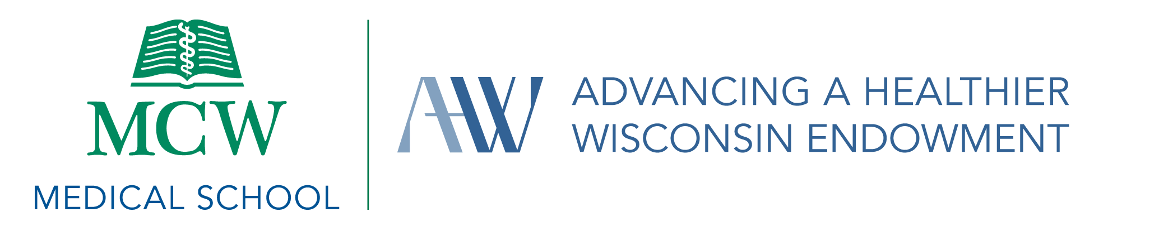

Non-Supplanting Attestation

Non-Supplanting Attestations are used to identify existing or available funding for each proposed project or used to determine whether such existing or available funding would be replaced with financial support by AHW funds. All key project partners, as indicated in the proposal instructions, must complete a separate Non-Supplanting Attestation.

Proposal and Contact Information

Project Title:
Name:
Email:
MCW Department:

Non-Supplanting Attestation
- Describe projects that the Investigator has previously done, or is currently doing, that are closely related to the proposed request (e.g. brief description, time period, funding).

- Describe other funding that the Investigator now has, or has had in the last three years, for the proposed project or closely related projects.

  - Federal funding
  - State/local government funding
  - Foundation funding
  - MCW corporate funding
  - Local community funding
  - Other funding

- Indicate whether the Investigator has applied to another funding source for the same or simlar project. If so, what was the date and result of that application, or when does the applicant expect to receive notification?

- Please indicate any other factors that would be relevant to the non-supplanting requirement.

